NEXTAG COMPANY

**Gucci Zumi grainy leather card case**

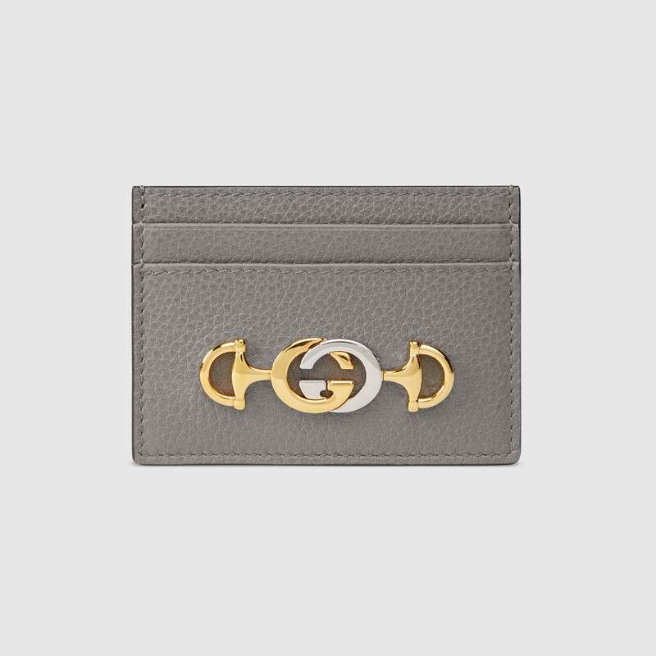

$ 290

Style # 570679 1B90X 1275

Product Description

Hybrid design elements continue to shape the Gucci narrative. The Interlocking G

Horsebit, a mix of two of the House's most distinctive codes, is presented on this dusty

grey slim leather card case in a dynamic mix of gold- and silver-toned metals. First

introduced in the evocative setting of the Théâtre Le Palace in Paris, the Gucci Zumi line

takes its name from actress and experimental musician Zumi Rosow, who walked the

Spring Summer 2019 runway carrying the bag.

Shiny gold- and silver-toned hardware • Gucci Zumi

• Interlocking G Horsebit—inspired by an archival piece, the hardware combines two of

the House's most historical motifs in a mix of metals

• Four card slots • Made in Italy

PRODUCT DETAILS

Style ‎602204 92TCG 8563

Introduced for Cruise 2020, the Gucci 1955 Horsebit bag is recreated from an archival design. With the same lines and forms first introduced over six decades ago, the accessory unifies the original details with a modern spirit, highlighting the Horsebit. Part of Gucci’s genetic code, the double ring and bar design has been established as one of the most distinctive elements among the House symbols borrowed from the equestrian world. Presented on a small flap shoulder bag, the hardware is paired with the House’s monogram fabric and completed with a special mechanism that adjusts the length of the shoulder strap so it can be carried on one shoulder or cross body.

* A limited time online exclusive, this bag will be available with early access on Gucci.com
* Beige/ebony GG Supreme canvas, a material with low environmental impact, with brown leather trim
* Gold-toned hardware
* Microfiber lining with a suede-like finish
* Each bag will ship with a small pouch containing two additional button covers that can be used to cover the exposed studs when the shoulder strap is lengthened
* Horsebit detail at the front
* Half Horsebit detail at each side
* Three gussets with one zipper and one open pocket
* Shoulder strap with snap buttons can be adjusted from a 9.8" to 17.7" drop
* Flap closure
* Small size: 9.8"W x 7"H x 3.1"D
* The model is 5'8" tall
* Made in Italy